Project title: Web site traffic analysis
C Shanmugapriya[812121106029]

Phase 1: Problem Definition and Design Thinking
In this part you will need to understand the problem statement and create a document on what have you understood and how will you proceed ahead with solving the problem. Please think on a design and present in form of a document.
Project Definition: The project involves analyzing website traffic data to gain insights into user behavior, popular pages, and traffic sources. The goal is to help website owners enhance the user experience by understanding how visitors interact with the site. This project encompasses defining the analysis objectives, collecting website traffic data, using IBM Cognos for data visualization, and integrating Python code for advanced analysis.

Design Thinking:
- Analysis Objectives:

With the rapid increasing popularity of the WWW, Websites are playing a crucial role to convey knowledge and information to the end users. Discovering hidden and meaningful information about web user’s usage patterns is critical to determine effective marketing strategies to optimize the Web server usage for accommodating future growth. Most of the currently available Web server traffic analysis tools explicitly provide statistical information. The web server traffic analysis tools make the use of Web Access Logs that are generated on the server while the user is accessing the website. A Web access log comprises of various entries like the name of the user, his IP address, number of bytes transferred timestamp etc. The task of web traffic analysis tools becomes more challenging when the web traffic volume is enormous and keeps on growing. In this paper, we propose a various model to discover and analyze useful knowledge from the available Web log data and also provides a comparative study of variety of Log Analyzer tools exist which helps in analyzing the traffic on web server.
- Data Collection: The web traffic starts with the high-level activities such as clicking a link and increases with low-level activities such as travelling through network switches and cables. In other words, Web traffic is usually initiated by users via the use of web browsers. It begins with a click to access a URL. Traffic flow starts with a mouse click, which sends browser information to a server that uses predetermined rules and methods to obtain user browser requests. Based on these rules, the server then decides what action is needed. Now a days, the web traffic is increases enormously because there is continuous increase of Internet users each year is motivating online shop, gambling site, and botnet owners to take control of users‘ moves to point them to their sites. Therefore, there is need of web traffic analysis tools. These tools handle and categorize the traffic and increase the workload handling capacity of the web server. B. LOGS Web server logs stores click stream data which can be useful for web traffic analysis purposes [3]. They are plain text (ASCII) files which contain information about User Name, IP Address, Time Stamp, Access Request, URL that Referred, error codes (if any) etc. and generally reside in the web servers. Traditionally there are four types of server logs: Transfer Log, Agent Log, Error Log and Referrer Log [4]. The Transfer and the Agent Log are said to be standard whereas the error and referrer log are considered optional as they may not be turned on. Every log entry records the traversal from one page to another, storing user IP number and all the related information [5]. If logs are utilized properly, it can be very useful in turning the websites visitors into customers especially in case of an e-commerce website. It guides the analyst in determining the navigational pattern of the user i.e. which pages are frequently visited by the user, the kind of errors that user gets, etc. A variety of tools are available that take the web access logs as an input and generate the reports as an output. These tools provide us with all sorts of information starting from how many hits the site getting to the number of visitors accessing the site, the browsers that they use the length of their stay, and much more. Some of the tools that are available are: 1) Google Analytics: It is a free utility provided by Google which helps in keeping a track of unique visitors. It also helps in determining which marketing packages are offering the best .For using this tool, installation is not required, only requires a Google account. Email report facility is available in Google analytics. 2) AWStats: It is available free of cost. This tool works as a CGI Script or from command line. It displays all sorts of information that the log contains. 3) WebLog Expert: Yet another log analyzer tool that provides thorough analysis of the web access logs. It provides the users with specific and precise information about user‘s statistics. It supports log files extracted from Apache and IIS. For using this tool, there is no need of creating any account but profile creation is required. 4) Analog: This is an easy to use and install freely available log analysis tool. It is extremely fast, highly scalable, works on any operating system and an easy to install tool.

Visualization:

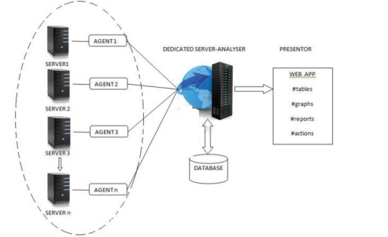

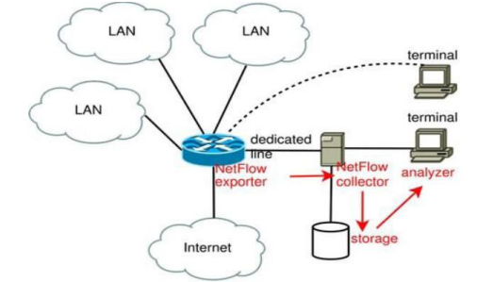
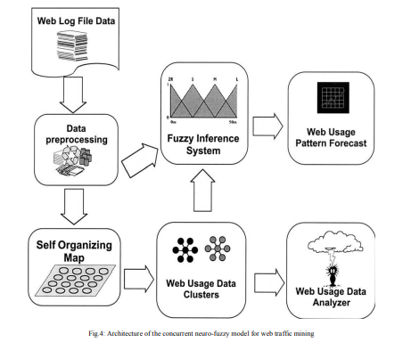
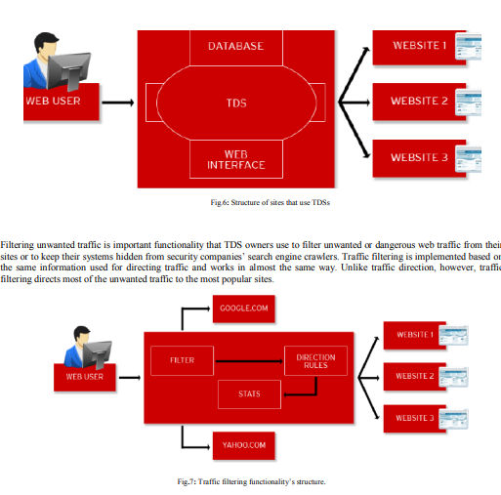
Fig.7 shows that web traffic is usually filtered then directed from the very beginning while writing information to a database or a text file at the same time for future statistical means. TDS owners that use the traffic filtering functionality usually redirect unwanted requests to the most popular legitimate sites in order to hide their systems‘ main function. For example, security companies that scan lists of possibly malicious URLs and IP addresses are filtered by malicious TDS owners to block the HTTP requests of antivirus crawlers. This instead directs security experts to non-malicious legitimate sites such as Yahoo! and Google.

INNOVATION FOR WEBSITE TRAFFIC ANALYSIS
Phase 2 Submission Document

Project Title: Website Traffic Analysis



Introduction:
Inthe digital age, where websites have become the primary source of information and business transactions, understanding and analyzing website traffic have become crucial. Website traffic analysis is the process of evaluating the behavior of visitors to a website, the pages they interact with, and the actions they take.

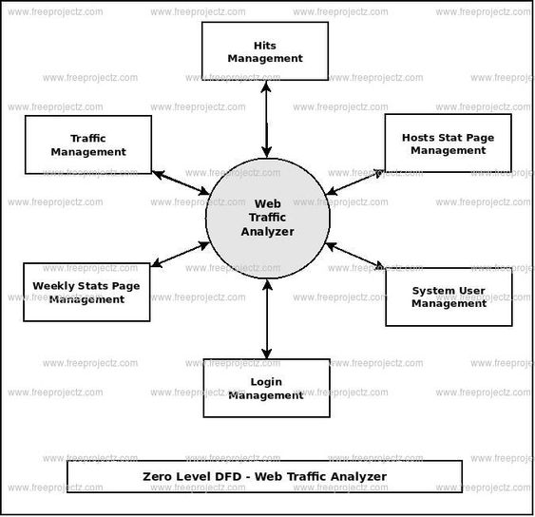
_{HITS MANAGEMENT:}
Managing hits in website traffic analysis refers to the process of monitoring, tracking, and analyzing the interactions and requests made to a website. Hits can encompass a wide range of data, such as page views, images, scripts, style sheets, and more. Managing hits is crucial for understanding website performance, user behavior, and making informed decisions for optimizing your website. Here's how you can manage hits in a website traffic analyze.

- Data Collection: To manage hits, you need a robust web analytics tool. There are various analytics platforms available, such as Google Analytics, Adobe Analytics, and many others. These tools collect data on every interaction or request made to your website.

- Differentiate Hits: Understand the various types of hits. Some common hit types include:
Page Views: When a user loads a web page.
Events : User interactions like clicks, form submissions, and video views.
Downloads: Tracking files downloaded from your website.
Outbound Links: Monitoring when users click on links leading awayfrom your site.
Images and Assets: Tracking requests for images, stylesheets, and scripts.
- Real-time Monitoring: Some analytics tools provide real-time tracking, allowing you to see hits as they happen. This can be useful for monitoring sudden spikes in traffic or identifying issues in real-time.
HOSTS STATE PAGE MANAGEMENT :
It seems like you're interested in managing the state of hostnames, IP addresses, or domain name mappings in a "hosts" file on a computer. The "hosts" file is a simple text file used to map hostnames to IP addresses and is commonly used to override DNS (Domain Name System) resolutions for specific domains. Below, I'll explain how to manage the hosts file state on various operating systems.

MacOS and Linux:
Editing the Hosts File: On macOS and Linux, the hosts file is usually located at `/etc/hosts`. You'll need root or superuser privileges to edit it.
Add/Modify Entries: Open the hosts file with a text editor, such as nano or vim, and add entries in the same format as shown above for Windows.
Save Changes:After editing, save the file.

SYSTEM USER MANAGEMENT :
User management refers to the process of controlling, tracking, and maintaining user accounts and their permissions within a computer system or an organization. This is an essential aspect of information security, access control, and ensuring that individuals have the right level of access to resources and data. User management typically includes tasks such as creating, modifying, and deleting user accounts, assigning or revoking privileges, and monitoring user activities for security and compliance purposes.
Here are some key aspects of user management:
- User Account Creation
- User Authentication
- User Authorization
- User Profile Management
- User Access Control
- User Deactivation/Deletion
- Password Management

LOGIN MANAGEMENT :
Implementing login management for a website traffic analyzer is an important aspect of ensuring that only authorized users can access and utilize the tool. Here's a general outline of how you can set up login management for your website traffic analyzer:
1.User Authentication
2.User Registration
3.User Database
4.Session Management ….etc

WEEKLY STATUS PAGE MANAGEMENT :
Managing a weekly status page for a website traffic analysis tool is crucial for keeping stakeholders informed about the performance and trends of the website. Here's how you can effectively manage a weekly status page.
TRAFFIC MANAGEMENT :
Traffic management in website traffic analysis refers to the strategies and techniques used to monitor, control, and optimize the flow of traffic to a website. Effective traffic management is essential for ensuring the performance, availability, and security of your website. Here are key aspects to consider. Website Traffic Analysis
Project Submission Part 3: Development Part 1
Title:DAC_Phase 3
Team leader: V.Sinthika/au812121106034
Members name: C.Shanmuga priya/812121106029
Time-series Database is the fastest-growing category of databases in the past two years, and both traditional and emerging technology industries have been generating more and more time-series data.
Now let’s try to understand the business use case that we tackling here.
The web traffic is basically the number of sessions in a given time frame, and it varies a lot with respect to what time of the day it is, what day of the week it is, and so on, and how much web traffic of platform can withstand depends on the size of the servers that are supporting the platform.
If the traffic is more than what the servers can handle, the website might show this 404 error, which is something we don’t want to happen. It will make the visitors go away.
One solution to this problem is to increase the number of servers. However, the downside of the solution is the cause can go up, which is again undesirable. So, what is the solution?
You can dynamically a lot of servers based on the historical visitor’s volume data or based on the historical web traffic data. And that brings us to the data science problem, which is basically forecasting the web traffic or a number of sessions based on the historical data.

We will deep dive into the web traffic data set and look at how we can use LSTM to solve this time series forecasting problem.
Now we will cover the problem statement of web traffic forecasting, and how it will help in scaling the resources, backing the outline publishing platform.
We will work with the web traffic dataset. It is a six-month series data set the link is given here Link.

Load Dataset for Web Traffic Forecasting
Here we are reading the dataset by using pandas. It has over 4800 observations.
import pandas as pd
import numpy as np
data=pd.read_csv('webtraffic.csv')
Check the shape of the data
data.shape
To print the first records of the dataset.
data.head()
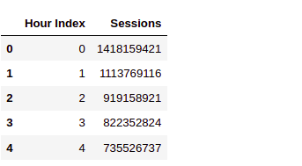
The first column is the hours as in this is the first hours, this is the second hour and so on.
And the second column session is the volume of traffic at an hourly level.
For example:- this is the number of sessions in the second hours and so on.

Data Exploration for Web Traffic Forecasting
Now let’s explore the data, we will use the below code to plot the entire time series there you go.
import matplotlib.pyplot as plt
sessions = data['Sessions'].values
ar = np.arange(len(sessions))
plt.figure(figsize=(22,10))
plt.plot(ar, sessions,'r')
plt.show()
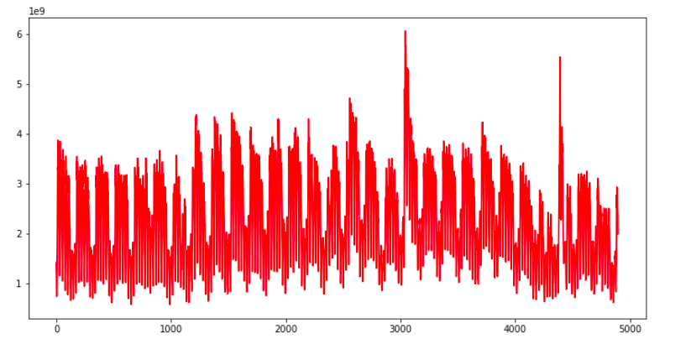
Each point of this curve is an early session count and you can see there are some repeating patterns throughout the time series.
The traffic volume comes down, after almost equal intervals of time. Apart from that, there are a couple of spikes as well in the traffic, In this plot.
Let’s explore this data, at a more granular level, we can use the below code and replace the entire time series, with a subset of it.
#first week web traffic
sample = sessions[:168]
ar = np.arange(len(sample))
plt.figure(figsize=(22,10))
plt.plot(ar, sample,'r')
plt.show()
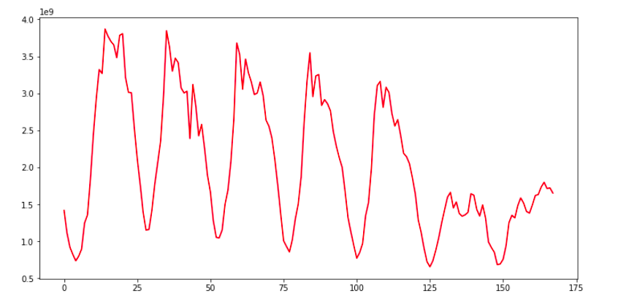
Here we are plotting the first week’s data only, now the repeating pattern can be seen more clearly, and these dips in the plot in web traffic are may be occurring once every 24 hours. So clearly there are two instances of time in a day, when we have a huge traffic volume, like during a few times and when we have a modest level of traffic on the website. As in here, I will help you to explore this data as much as possible, before getting started with model building.

Data Preparation for Web Traffic Forecasting
Moving on now let’s prepare the data for model training, here we will create input sequences, from the block traffic data. Let’s say this is a time series. Each cell would have some number or value. Let’s create sequences of length five, so the first five observations, will form the first sequence, and the sixth observation, this one will be treated as the target.
The second sequence will start from the second element, till the sixth element and the target will be the seventh element.
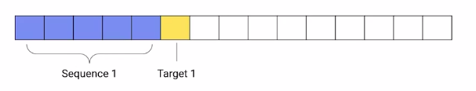

Now the subsequent sequences will be extracted, by moving this window, one step at a time.
def prepare_data(seq,num):
x=[]
y=[]
for i in range(0,(len(seq)-num),1):

input_ = seq[i:i+num]
output = seq[i+num]

x.append(input_)
y.append(output)

return np.array(x), np.array(y)
In this function, prepare_data. We are using the same technique to create sequences from time-series data. We have specified the sequence length of one week or 168 hours.
num=168
x,y= prepare_data(sessions,num)
print(len(x))
Now here we are calling this function to create sequences. The sequence length we have specified is 168 hours and that is equivalent to one week. So we are creating sequences of one week, as our input sequences. Now the number of sequences are well over 4700.

Split the Dataset
Next, we have to split the data into a training set and validation set and we will do this in the ratio, 90 is to 10. Now that sense it is a time serious problem, we are not splitting the data randomly, we are splitting it in a sequential manner. As you can see the code below.
ind = int(0.9 * len(x))
x_tr = x[:ind]
y_tr = y[:ind]
x_val=x[ind:]
y_val=y[ind:]
nowhere in the code we would scale the data, Both the input sequences and the target values, will be scaled because of scaling the data, speeds because of scaling the data, speeds of the model training process.
from sklearn.preprocessing import StandardScaler
#normalize the inputs
x_scaler= StandardScaler()
x_tr = x_scaler.fit_transform(x_tr)
x_val= x_scaler.transform(x_val)
#reshaping the output for normalization
y_tr=y_tr.reshape(len(y_tr),1)
y_val=y_val.reshape(len(y_val),1)
#normalize the output
y_scaler=StandardScaler()
y_tr = y_scaler.fit_transform(y_tr)[:,0]
y_val = y_scaler.transform(y_val)[:,0]
After that, we are reshaping the data from two dimensional to 3 dimensional.
#reshaping input data
x_tr= x_tr.reshape(x_tr.shape[0],x_tr.shape[1],1)
x_val= x_val.reshape(x_val.shape[0],x_val.shape[1],1)
print(x_tr.shape)
The first dimension of our data is the number of sequences, and the second dimension is the number of elements in the sequences. But LSTM layer accepts only three-dimensional data.

These three dimensions are the number of sequences number of time steps and the length of the features. So third dimension is the length of the vectors of the sequence elements.
Let’s say I have five elements in my sequence and each of these elements has a vector length of 10. So this third dimension will become 10. If you can recall in the case of the auto-tagging projects the length of the sequence elements was nothing but the length of the word embeddings.
However in this dataset, the sequence elements are real number values and therefore the feature length is just one, hence we would reshape both the training set and the validation set as shown in the above code. Now, the data is ready for model training.
In the next section, we will build our deep learning model to predict traffic using LSTM.

Model Building for Web Traffic Forecasting
In the previous section, we covered how time-series data is converted into sequences to train data.
And now we will use these sequences to train a deep learning model to predict future web traffic. The first thing that we do is define the model architecture.
from keras.models import *
from keras.layers import *
from keras.callbacks import *
from tensorflow import keras
# define model
model = Sequential()
model.add(LSTM(128,input_shape=(168,1)))
model.add(Dense(64,activation='relu'))
model.add(Dense(1,activation='linear'))
Have a look at the activation at the final layer above the code It is linear. This is because we have to predict a continuous value and not some class tag or category as it is a regression problem and not a classification problem. Other than that we are using a single layer of LSTM here and the input shape is 168 that is one week.
model.summary()
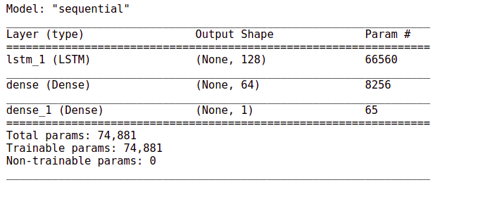
The number of train parameters is just around 74000.
# Define the optimizer and loss
model.compile(loss='mse',optimizer='adam')
#Define the callback to save the best model during the training
mc = ModelCheckpoint('best_model.hdf5', monitor='val_loss',
verbose=1, save_best_only=True, mode='min')
# Train the model for 30 epochs with batch size of 32:
history=model.fit(x_tr, y_tr ,epochs=30, batch_size=32,
validation_data=(x_val,y_val), callbacks=[mc])

The output will be:-
Epoch 1/30
133/133 [==============================] – 15s 101ms/step – loss: 0.1409 – val_loss: 0.0339
Epoch 00001: val_loss improved from inf to 0.03390, saving model to best_model.hdf5
Epoch 2/30
133/133 [==============================] – 17s 126ms/step – loss: 0.0394 – val_loss: 0.0286
Epoch 00002: val_loss improved from 0.03390 to 0.02865, saving model to best_model.hdf5
Epoch 3/30
133/133 [==============================] – 19s 142ms/step – loss: 0.0369 – val_loss: 0.0265
Epoch 00003: val_loss improved from 0.02865 to 0.02647, saving model to best_model.hdf5
Epoch 4/30
133/133 [==============================] – 19s 142ms/step – loss: 0.0332 – val_loss: 0.0269
Epoch 00004: val_loss did not improve from 0.02647
Epoch 5/30
133/133 [==============================] – 18s 137ms/step – loss: 0.0329 – val_loss: 0.0240
Epoch 00005: val_loss improved from 0.02647 to 0.02402, saving model to best_model.hdf5
Epoch 6/30
133/133 [==============================] – 19s 143ms/step – loss: 0.0303 – val_loss: 0.0250

Blogathon is Live AGAIN !
Get Assured Rs 2000 for Every Published Article!
Get 2x Rewards for Gen AI Articles!
Register Now
Epoch 00006: val_loss did not improve from 0.02402
Epoch 7/30
133/133 [==============================] – 21s 155ms/step – loss: 0.0283 – val_loss: 0.0248
Epoch 00007: val_loss did not improve from 0.02402
Epoch 8/30
133/133 [==============================] – 21s 156ms/step – loss: 0.0290 – val_loss: 0.0211
Epoch 00008: val_loss improved from 0.02402 to 0.02107, saving model to best_model.hdf5
Epoch 9/30
133/133 [==============================] – 19s 146ms/step – loss: 0.0269 – val_loss: 0.0231
Epoch 00009: val_loss did not improve from 0.02107
Epoch 10/30
133/133 [==============================] – 19s 140ms/step – loss: 0.0269 – val_loss: 0.0241
Epoch 00010: val_loss did not improve from 0.02107
Epoch 11/30
133/133 [==============================] – 18s 138ms/step – loss: 0.0252 – val_loss: 0.0201
Epoch 00011: val_loss improved from 0.02107 to 0.02014, saving model to best_model.hdf5
Epoch 12/30
133/133 [==============================] – 19s 144ms/step – loss: 0.0237 – val_loss: 0.0199
Epoch 00012: val_loss improved from 0.02014 to 0.01994, saving model to best_model.hdf5
Epoch 13/30
133/133 [==============================] – 27s 201ms/step – loss: 0.0215 – val_loss: 0.0160
Epoch 00013: val_loss improved from 0.01994 to 0.01602, saving model to best_model.hdf5
Epoch 14/30
133/133 [==============================] – 23s 170ms/step – loss: 0.0197 – val_loss: 0.0202
Epoch 00014: val_loss did not improve from 0.01602
Epoch 15/30
133/133 [==============================] – 17s 127ms/step – loss: 0.0188 – val_loss: 0.0168
Epoch 00015: val_loss did not improve from 0.01602
Epoch 16/30
133/133 [==============================] – 17s 127ms/step – loss: 0.0179 – val_loss: 0.0173
Epoch 00016: val_loss did not improve from 0.01602
Epoch 17/30
133/133 [==============================] – 17s 125ms/step – loss: 0.0179 – val_loss: 0.0188
Epoch 00017: val_loss did not improve from 0.01602
Epoch 18/30
133/133 [==============================] – 17s 127ms/step – loss: 0.0171 – val_loss: 0.0140
Epoch 00018: val_loss improved from 0.01602 to 0.01395, saving model to best_model.hdf5
Epoch 19/30
133/133 [==============================] – 18s 133ms/step – loss: 0.0165 – val_loss: 0.0155
Epoch 00019: val_loss did not improve from 0.01395
Epoch 20/30
133/133 [==============================] – 17s 127ms/step – loss: 0.0165 – val_loss: 0.0216
Epoch 00020: val_loss did not improve from 0.01395
Epoch 21/30
133/133 [==============================] – 17s 126ms/step – loss: 0.0160 – val_loss: 0.0166
Epoch 00021: val_loss did not improve from 0.01395
Epoch 22/30
133/133 [==============================] – 17s 125ms/step – loss: 0.0165 – val_loss: 0.0158
Epoch 00022: val_loss did not improve from 0.01395
Epoch 23/30
133/133 [==============================] – 17s 126ms/step – loss: 0.0161 – val_loss: 0.0166
Epoch 00023: val_loss did not improve from 0.01395
Epoch 24/30
133/133 [==============================] – 17s 128ms/step – loss: 0.0158 – val_loss: 0.0150
Epoch 00024: val_loss did not improve from 0.01395
Epoch 25/30
133/133 [==============================] – 17s 127ms/step – loss: 0.0164 – val_loss: 0.0164
Epoch 00025: val_loss did not improve from 0.01395
Epoch 26/30
133/133 [==============================] – 17s 131ms/step – loss: 0.0158 – val_loss: 0.0179
Epoch 00026: val_loss did not improve from 0.01395
Epoch 27/30
133/133 [==============================] – 17s 127ms/step – loss: 0.0155 – val_loss: 0.0159
Epoch 00027: val_loss did not improve from 0.01395
Epoch 28/30
133/133 [==============================] – 17s 127ms/step – loss: 0.0153 – val_loss: 0.0141
Epoch 00028: val_loss did not improve from 0.01395
Epoch 29/30
133/133 [==============================] – 17s 128ms/step – loss: 0.0149 – val_loss: 0.0260
Epoch 00029: val_loss did not improve from 0.01395
Epoch 30/30
133/133 [==============================] – 17s 128ms/step – loss: 0.0154 – val_loss: 0.0145
Epoch 00030: val_loss did not improve from 0.01395
Load the weights of the best model prior to predictions. Now here we will use the mean squared error and we are using model checkpoint again to save the best model weight.
model.load_weights('best_model.hdf5')
finally, the model training starts and moving on the evaluation starts here and moving on to the evaluation part, the mean squared error for the validation data is just 0.013. Evaluate the performance of the model on the validation data.
mse = model.evaluate(x_val,y_val)
print("Mean Square Error:",mse)
Now, whenever we are working on a project it is always a good practice to have a baseline model, just to have an idea of how good your model is with respect to the baseline predictions.

Baseline Model with Forecasting
So here we are using a simple moving average as the baseline model. So what we will do, we will take a sequence and its length is the same 168 elements. And then we take average this sequence and we compare this average with the target value.
# build a simple moving average model
def compute_moving_average(data):
pred=[]
for i in data:
avg=np.sum(i)/len(i)
pred.append(avg)
return np.array(pred)
# reshape the data
x_reshaped = x_val.reshape(-1,168)
# get predictions
y_pred = compute_moving_average(x_reshaped)
So this function computes the average of the input sequences and over here we are extracting the predictions.
# evaluate the performance of model on the validation data
mse = np.sum ( (y_val - y_pred) **2 ) / (len(y_val))
print("Mean square of error:- ",mse)
Now we calculate the mean squared error for this model. On the same validation data, we get a score of 0.554 which is way higher than this previous error.
So our LSTM based model has done exceptionally well as compared to the baseline model,

Web Traffic Forecasting
Now moving on to forecasting. These are the steps that we will follow:-
- first, initialize an array with weeks data,
- Predict the next hour traffic volume
- Append the predicted value at the end of the array ‘data
- Skip the first element of the array ‘data’
- Repeating steps, from the second step till the fourth step for the specified number of iterations.
This is how we can forecasting for any number of hours in future. This function forecast performs the steps just discuss and it returns the predicted sequence of numbers.
def forecast(x_val, no_of_pred, ind):
predictions=[]
#intialize the array with a weeks data
temp=x_val[ind]
for i in range(no_of_pred):
#predict for the next hour
pred=model.predict(temp.reshape(1,-1,1))[0][0]

#append the prediction as the last element of array
temp = np.insert(temp,len(temp),pred)
predictions.append(pred)
#ignore the first element of array
temp = temp[1:]
return predictions
It’s time to forecast the traffic for the next 24 hours based on the previous week data.
no_of_pred =24
ind=72
y_pred= forecast(x_val,no_of_pred,ind)
y_true = y_val[ind:ind+(no_of_pred)]
# Lets convert back the normalized values to the original dimensional space
y_true= y_scaler.inverse_transform(y_true)
y_pred= y_scaler.inverse_transform(y_pred)
Now let’s look at the plot of real vs forecast values.
def plot(y_true,y_pred):
ar = np.arange(len(y_true))
plt.figure(figsize=(22,10))
plt.plot(ar, y_true,'r')
plt.plot(ar, y_pred,'y')
plt.show()
plot(y_true,y_pred)
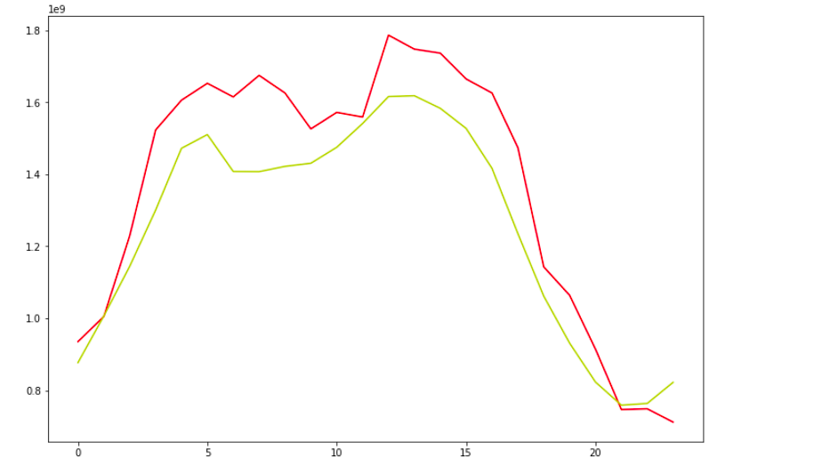
It looks great. Our model has been successful in capturing the trend.
This red curve is the actual value and this yellow curve are the predicted values both are pretty much close to each other.
Similarly, we can use a CNN based model in place of LSTM to perform the same task. Let’s see how it is done.

CNN Model with Forecasting
Now here we are using Conv1D layers in the model architecture. And these layers are followed by a flattening layer. This layer converts the input to a One Dimensional array, which is then passed on to this set of dense layers.
from tensorflow.keras.models import Sequential
from tensorflow.keras.layers import *
from tensorflow.keras.callbacks import *
model= Sequential()
model.add(Conv1D(64, 3, padding='same', activation='relu',input_shape=(num,1)))
model.add(Conv1D(32, 5, padding='same', activation='relu',input_shape=(num,1)))
model.add(Flatten())
model.add(Dense(64,activation='relu'))
model.add(Dense(1,activation='linear'))
model.summary()
The output will be:-
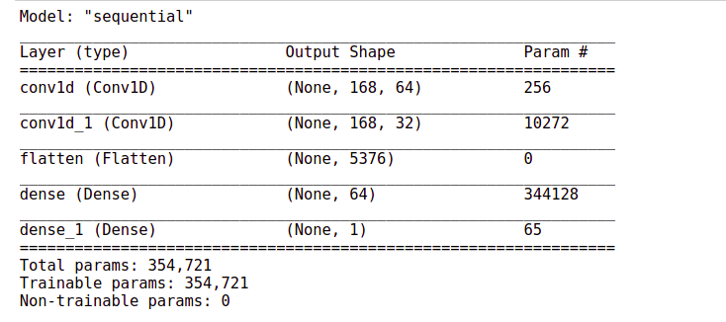
# Define the optimizer and loss:
model.compile(loss='mse',optimizer='adam')
# Define the callback to save the best model during the training
mc = ModelCheckpoint('best_model.hdf5', monitor='val_loss', verbose=1,
save_best_only=True, mode='min')
# Train the model for 30 epochs with batch size of 32:
history=model.fit(x_tr, y_tr ,epochs=30, batch_size=32, validation_data=(x_val,y_val),
callbacks=[mc])
Here again, you can see that the training process is processing fast. It is hardly taking one second to finish and pip off.
Epoch 1/30
133/133 [==============================] - 4s 23ms/step - loss: 0.0899 - val_loss: 0.0482

Epoch 00001: val_loss improved from inf to 0.04819, saving model to best_model.hdf5
Epoch 2/30
133/133 [==============================] - 3s 22ms/step - loss: 0.0249 - val_loss: 0.0209

Epoch 00002: val_loss improved from 0.04819 to 0.02086, saving model to best_model.hdf5
Epoch 3/30
133/133 [==============================] - 3s 22ms/step - loss: 0.0186 - val_loss: 0.0190

Epoch 00003: val_loss improved from 0.02086 to 0.01899, saving model to best_model.hdf5
Epoch 4/30
133/133 [==============================] - 3s 23ms/step - loss: 0.0157 - val_loss: 0.0161

Epoch 00004: val_loss improved from 0.01899 to 0.01610, saving model to best_model.hdf5
Epoch 5/30
133/133 [==============================] - 3s 20ms/step - loss: 0.0132 - val_loss: 0.0149

Epoch 00005: val_loss improved from 0.01610 to 0.01490, saving model to best_model.hdf5
Epoch 6/30
133/133 [==============================] - 3s 21ms/step - loss: 0.0134 - val_loss: 0.0158

Epoch 00006: val_loss did not improve from 0.01490
Epoch 7/30
133/133 [==============================] - 3s 22ms/step - loss: 0.0122 - val_loss: 0.0138

Epoch 00007: val_loss improved from 0.01490 to 0.01385, saving model to best_model.hdf5
Epoch 8/30
133/133 [==============================] - 3s 23ms/step - loss: 0.0112 - val_loss: 0.0146

Epoch 00008: val_loss did not improve from 0.01385
Epoch 9/30
133/133 [==============================] - 3s 21ms/step - loss: 0.0106 - val_loss: 0.0177

Epoch 00009: val_loss did not improve from 0.01385
Epoch 10/30
133/133 [==============================] - 3s 21ms/step - loss: 0.0092 - val_loss: 0.0131

Epoch 00010: val_loss improved from 0.01385 to 0.01314, saving model to best_model.hdf5
Epoch 11/30
133/133 [==============================] - 3s 23ms/step - loss: 0.0089 - val_loss: 0.0167

Epoch 00011: val_loss did not improve from 0.01314
Epoch 12/30
133/133 [==============================] - 3s 22ms/step - loss: 0.0083 - val_loss: 0.0148

Epoch 00012: val_loss did not improve from 0.01314
Epoch 13/30
133/133 [==============================] - 3s 21ms/step - loss: 0.0078 - val_loss: 0.0154

Epoch 00013: val_loss did not improve from 0.01314
Epoch 14/30
133/133 [==============================] - 3s 21ms/step - loss: 0.0073 - val_loss: 0.0142

Epoch 00014: val_loss did not improve from 0.01314
Epoch 15/30
133/133 [==============================] - 3s 21ms/step - loss: 0.0064 - val_loss: 0.0144

Epoch 00015: val_loss did not improve from 0.01314
Epoch 16/30
133/133 [==============================] - 3s 22ms/step - loss: 0.0057 - val_loss: 0.0153

Epoch 00016: val_loss did not improve from 0.01314
Epoch 17/30
133/133 [==============================] - 3s 22ms/step - loss: 0.0050 - val_loss: 0.0158

Epoch 00017: val_loss did not improve from 0.01314
Epoch 18/30
133/133 [==============================] - 3s 22ms/step - loss: 0.0051 - val_loss: 0.0155

Epoch 00018: val_loss did not improve from 0.01314
Epoch 19/30
133/133 [==============================] - 3s 20ms/step - loss: 0.0044 - val_loss: 0.0153

Epoch 00019: val_loss did not improve from 0.01314
Epoch 20/30
133/133 [==============================] - 3s 21ms/step - loss: 0.0040 - val_loss: 0.0144

Epoch 00020: val_loss did not improve from 0.01314
Epoch 21/30
133/133 [==============================] - 3s 22ms/step - loss: 0.0033 - val_loss: 0.0147

Epoch 00021: val_loss did not improve from 0.01314
Epoch 22/30
133/133 [==============================] - 3s 20ms/step - loss: 0.0031 - val_loss: 0.0153

Epoch 00022: val_loss did not improve from 0.01314
Epoch 23/30
133/133 [==============================] - 3s 22ms/step - loss: 0.0030 - val_loss: 0.0161

Epoch 00023: val_loss did not improve from 0.01314
Epoch 24/30
133/133 [==============================] - 3s 22ms/step - loss: 0.0026 - val_loss: 0.0150

Epoch 00024: val_loss did not improve from 0.01314
Epoch 25/30
133/133 [==============================] - 3s 23ms/step - loss: 0.0025 - val_loss: 0.0161

Epoch 00025: val_loss did not improve from 0.01314
Epoch 26/30
133/133 [==============================] - 3s 21ms/step - loss: 0.0026 - val_loss: 0.0151

Epoch 00026: val_loss did not improve from 0.01314
Epoch 27/30
133/133 [==============================] - 3s 20ms/step - loss: 0.0026 - val_loss: 0.0151

Epoch 00027: val_loss did not improve from 0.01314
Epoch 28/30
133/133 [==============================] - 3s 21ms/step - loss: 0.0023 - val_loss: 0.0160

Epoch 00028: val_loss did not improve from 0.01314
Epoch 29/30
133/133 [==============================] - 3s 22ms/step - loss: 0.0022 - val_loss: 0.0145

Epoch 00029: val_loss did not improve from 0.01314
Epoch 30/30
133/133 [==============================] - 3s 23ms/step - loss: 0.0020 - val_loss: 0.0161

Epoch 00030: val_loss did not improve from 0.01314
Load the weights of the best model prior to predictions.
model.load_weights('best_model.hdf5')
Let’s check out the performance of this model on the validation set. Evaluate the performance of a model on the validation data.
mse = model.evaluate(x_val,y_val)
print("Mean Square Error:",mse)
The mean squared error has improved the width from 0.015 to 0.013.

Comparison with the baseline model
Now let’s compare this performance with the baseline model.
#build a simple model
def compute_moving_average(data):
pred=[]
for i in data:
avg=np.sum(i)/len(i)
pred.append(avg)
return np.array(pred)
x_reshaped = x_val.reshape(-1,168)
y_pred = compute_moving_average(x_reshaped)
mse = np.sum ( (y_val - y_pred) **2 ) / (len(y_val))
print("Mean Square Error:",mse)
The baseline score was 0.55. So our CNN based model is also much better than the baseline model.

Forecasting
Now let’s see how well it forecast the web traffic for a period of 24 hours.
def forecast(x_val, no_of_pred, ind):
predictions=[]
#intialize the array with previous weeks data
temp=x_val[ind]
for i in range(no_of_pred):
#predict for the next hour
pred=model.predict(temp.reshape(1,-1,1))[0][0]

#append the prediction as the last element of array
temp = np.insert(temp,len(temp),pred)
predictions.append(pred)
#ignore the first element of array
temp = temp[1:]
return predictions
It’s time to forecast the traffic for the next 24 hours based on the previous week data.
no_of_pred =24
ind=72
y_pred= forecast(x_val,no_of_pred,ind)
y_true = y_val[ind:ind+(no_of_pred)]
Let’s convert back the normalized values to the original dimensional space.
y_true= y_scaler.inverse_transform(y_true)
y_pred= y_scaler.inverse_transform(y_pred)
def plot(y_true,y_pred):
ar = np.arange(len(y_true))
plt.figure(figsize=(22,10))
plt.plot(ar, y_true,'r')
plt.plot(ar, y_pred,'y')
plt.show()
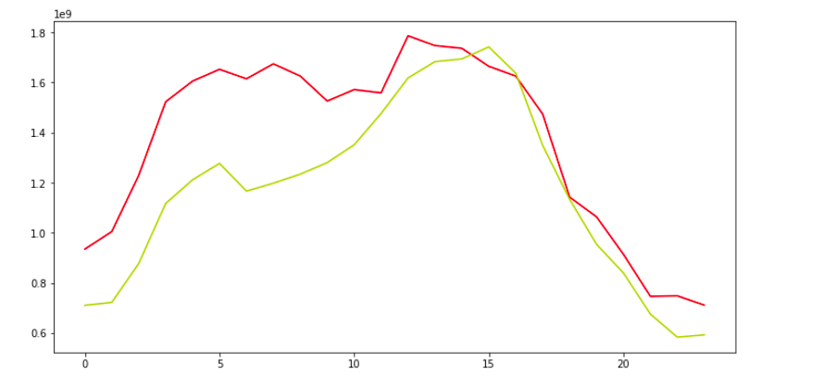

The forecasted values are almost close to the actual values. Well, the performance seems pretty much similar to that of the LSTM in the based model.
If You can recall in the Auto-tagging system project we saw that the CNN-based model outperform the LSTM based model by a huge margin.
But here in this case both the models have performed mode or less the same.

Conclusion
However, the CNN-based model still has the advantage of speed. Now, this is not the end of the row. We can further improve this model by taking measures like, we can make the time series data stationary and then use it for making sequences and then later use it in the model input sequences. To learn more about stationarity charity and other time series-related concepts, you can check out this link.
Apart from that, we can also try a different number of hidden units r different numbers of hidden layers. To see how our model performs under different settings. In addition, we can also try to change the learning rate. Even that might help in improving the model.

ANALYSING WEBSITE TRAFFIC USING PYTHON
Project Tittle: Website Traffic Analysis
Phase 4: Development Part 2

Website Traffic Analysis
Introduction:
- Website traffic analysis is the process of monitoring, assessing, and interpreting the data related to the visitors who land on a website. It involves collecting a wealth of information about user behavior, such as which pages they visit, how long they stay, and how they arrived at the site. This data provides invaluable insights into the effectiveness of a website's content, design, and marketing efforts.
- Why is website traffic analysis important? Simply put, it empowers website owners, marketers, and webmasters to make data-driven decisions that can have a profound impact on their online presence.
- Whether you're a business owner looking to increase your online sales, a blogger seeking to grow your readership, or a nonprofit organization aiming to reach a wider audience, website traffic analysis is the key to optimizing your web presence and achieving your goals.
- In this guide, we'll delve into the world of website traffic analysis, exploring the tools, techniques, and strategies that can help you make the most of your online presence.

Givendata set:
Overview of the process:
The following is an overview of the process of building a website traffic analysis model by performing different activities like feature engineering, model training and evaluation.
Model training:
Training the model with Prophet is really easy. The team copied the mechanism used is scikit packages: fit() and predict()

Creating a model:
So first we create the model. There are numerous variations that can be added. I will explain my choices below.
model = Prophet(changepoint_prior_scale=0.5, changepoint_range=0.9, seasonality_mode='multiplicative', yearly_seasonality = 10)model.fit(df)
- Change point prior scale: to cope with the under fitting, Increasing makes the trends more flexible (so visually broadening the end funnel)
- Change point range: By default, Prophet changes the slope of the trend only of the first 80% of the data. I here set 0.9 for it to include 90% of the data.
- Seasonality mode=’multiplicative’ as parameters, because the seasonality grows in influence. We clearly see that our business is growing following a multiplicative trend and not a linear one.
- Yearly seasonality = 20. It was 10 but I want more. This number represents Fourier’s Order.
2.Building the forecast timestamp set:
Until now, we have trained our model on our previous data. In order to forecast future web traffic, we first need to create future timestamps. Here I will create 60 days, so two months in the future.
#Forecasting
future = model.make_future_dataframe(periods= 60)
future['cap'] = 120
future['floor'] = 0
print(future.tail())

Predicting the future:
Here we go. In the next two lines, we will finally forecast our website traffic from Google Analytics.
forecast = model.predict(future)
model.plot(forecast)
And Voilà! We can see the beauty of my traffic jumping off the cliff in November and December.

4. Analyzing components:
Now Prophet has another great function: it can show the different components in a graph.
model.plot _components(forecast)

Feature engineering:
Website traffic feature engineering involves creating and transforming data features to better understand and analyze website traffic. This process is crucial for improving the performance of your website, user experience, and marketing efforts. Here are some key features you can engineer for website traffic analysis:
1. Page Views:
Track the number of views for each page on your website. You can break this down by individual pages or by categories.
2. Unique Visitors:
Differentiating between new and returning visitors can help you understand user engagement and the effectiveness of your content.
3. Bounce Rate:
Measure the percentage of visitors who leave your site after viewing only one page. High bounce rates may indicate issues with content or site design.
4. Time on Page:
Calculate the average time users spend on each page. This can help you identify which pages are the most engaging.
5. Session Duration:
Track how long users stay on your site during a single visit. This is important for understanding user engagement.
6. Traffic Sources:
Categorize traffic sources into organic search, direct, referral, and social. This information helps you understand where your visitors are coming from.
7. Geo location:
Determine the geographical location of your visitors. This can help you tailor content or marketing efforts to specific regions.
8. Device and Browser Type:
Know what devices (desktop, mobile, tablet) and browsers your visitors are using. This can inform your website's responsiveness and compatibility.
9. Conversion Rate:
Measure the percentage of visitors who complete a desired action, such as signing up for a newsletter or making a purchase.
10. Exit Pages:
Identify the last pages users visit before leaving your site. This can help you identify weak points in the user journey.
11. User Demographics:
If possible, collect data on user demographics like age, gender, and interests. This can help you tailor content and advertising.

12. Page Load Times:
Slow-loading pages can deter users. Measure and optimize page load times.
13. "Scroll Depth":
Determine how far users scroll down a page. This can help you understand which content is most engaging.
14. Engagement Events:
Track interactions like clicks on specific elements (buttons, links, videos) to understand user behavior.
15. Site Search Queries:
If your site has a search feature, track the queries users are making. This can reveal user intent and content gaps.
16. User Segmentation:
Segment your audience based on behavior, interests, or demographics to personalize content and marketing efforts.
17. A/B Testing Data:
If you're running A/B tests, collect data on the performance of different variations to optimize your site.
18. Cohort Analysis:
Group users based on specific criteria (e.g., sign-up date) to analyze how different user groups behave over time.

19. Content Tags:
Tag content with relevant keywords or categories to make it easier to analyze which types of content are performing well.
20. Event Tracking:
Implement event tracking to monitor specific user interactions, such as form submissions, downloads, or video views.
Remember that the key to effective feature engineering for website traffic is to collect and analyze the data that is most relevant to your specific goals and to use this data to make informed decisions about how to improve your website, increase user engagement, and achieve your desired outcomes.

Model evaluation:
Model evaluation in website traffic analysis is crucial to assessing the performance and effectiveness of the models used to analyse and understand user behaviour on a website. Below are some key considerations and methods for evaluating models in this context:

- Data Preparation:
Data Collection: Ensure that you have collected comprehensive and representative data about website traffic. This may include user interactions, page views, clickstreams, and other relevant information.
Data Cleaning: Remove outliers, handle missing data, and preprocess data to make it suitable for modelling.
2. Splitting Data:
Split your dataset into training, validation, and testing sets. Common splits include 70% for training, 15% for validation, and 15% for testing.
3. Cross-Validation:
Implement k-fold cross-validation to assess model performance - across different subsets of your data. This helps ensure your model is not over fitting to a specific data split.
4. Time Series Analysis:
If your website traffic data is time-series data, consider time-based evaluation metrics, such as mean absolute percentage error (MAPE) or root mean square error (RMSE), and examine forecast accuracy over different time periods.

Program:
import pandas as pd

# Sample website traffic data (hypothetical data)
data = {
'Date': ['2023-10-01', '2023-10-02', '2023-10-03', '2023-10-04', '2023-10-05'],
'PageViews': [1000, 1200, 900, 1100, 950],
'BounceRate': [0.45, 0.40, 0.50, 0.38, 0.42],
'Conversions': [20, 22, 18, 24, 21]}

# Create a DataFrame from the sample data
df = pd.DataFrame(data)

# Calculate key metrics
total_page_views = df['PageViews'].sum()
average_bounce_rate = df['BounceRate'].mean()
total_conversions = df['Conversions'].sum()
conversion_rate = (total_conversions / total_page_views) * 100

# Print the metrics
print(f"Total Page Views: {total_page_views}")
print(f"Average Bounce Rate: {average_bounce_rate:.2%}")
print(f"Total Conversions: {total_conversions}")
print(f"Conversion Rate: {conversion_rate:.2f}%")

Output:
Total Page Views: 5150
Average Bounce Rate: 42.00%
Total Conversions: 105
Conversion Rate: 2.04%
- These metrics provide a basic understanding of the website's performance.In a real-world scenario, you would fetch data from web analytics services or your own website logs and perform more advanced analysis and visualizations to gain deeper insights into user behaviour, traffic sources, and content performance. The Python libraries you use for this task will depend on the specific data source and analysis requirements.
Visualization:
- Create visualizations to present your results effectively, such as time series plots, ROC curves, or confusion matrices.
- Website traffic analysis is a dynamic field, and the evaluation process should adapt to the specific goals and characteristics of the website and the models being used. Regularly re-evaluate and update your models as the website and user behaviour evolve.

Conclusion:
- Analyzing and forecasting website traffic potential allows you to find out the prospects for the improvement of your own website, and keep up with your competitors.
- Based on the results you have obtained, you can draw up a realistic website promotion and improvement plan, taking into account the competitive landscape of the market and potential opportunities for website optimization.

